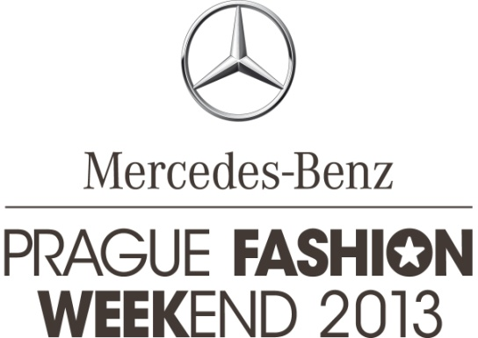

PRESS RELEASE | Prague, on June 19, 2013

SLOVAK TOP MODEL VIERA SCHOTTERTOVÁ TO BECOME THE FACE
OF MERCEDES-BENZ PRAGUE FASHION WEEKEND 2013

At a press conference held today in the InterContinental hotel the face of Mercedes-Benz Prague Fashion Weekend 2013 was introduced. After last year’s campaign featuring Simona Krainová, the torch is now passed on to the Slovak top model Viera Schottertová. The Mercedes-Benz Prague Fashion Weekend project has grown bigger with more than 35 Czech designers and 7 fashion brands confirming their participation. The accompanying programme includes Fashion Showroom, exhibitions, and competitions seeking to support young fashion designers as well as fashion photographers to name just a few highlights.

The key visual of Prague and Bratislava Fashion Weekend 2013 introduces woman as a strong personality that remains fragile on the inside. In its sensual mystery she reveals her natural beauty and a clear style emphasising her uniqueness. “The top model Viera Shottertová and the resulting key visual make our vision come true," says Olo Křížová, the project's creative director. Viera Schottertová is one of our most successful models; already at age 15 she won a prestigious modelling contest that enabled her to get her foot in the door of the global modelling business. During her successful career she spent 12 years in New York working for globally recognised brands. Her work includes campaigns for Chanel and Rimmel beauty brands. She was also featured in campaigns of Armani, Gant as well as the prestigious Victoria’s Secret. Together with Karolína Kurková she is one of the only two Czech and Slovak models who received the invitation to be featured in campaigns for the Mango fashion brand.

“Mercedes-Benz Prague Fashion Weekend is one of just a few projects in my home country that I decided to endorse. I was convinced by its vision, mission and above all its high level of professionalism. I’m really glad that the format of a global fashion week has finally arrived in our country as well,“ Viera Schottertová commented at the press conference.

Mercedes-Benz Prague Fashion Weekend is similarly to all other fashion weeks focused primarily on the support of the local fashion market. At the current moment more than 35 Czech designers and 7 fashion brands have confirmed their attendance of the fashion event. You can therefore look forward to Kateřina Geislerová, Jakub Polanka, Hana Stocklassová, Petra Balvínová, Hana Havelková, Chatty, Pavel Brejcha, Vladimír Staněk and many others. They will introduce themselves to visitors from September 18 to September 22, 2013 in an attractive zone close to Pařížská in a fashion tent. The tent has a capacity of 600 seating and 100 standing visitors. The press conference was joined also by Tamara Kotvalová, owner of the Simple Concept Store boutique who introduced the activities under preparation for Mercedes-Benz Prague Fashion Weekend 2013. The exclusive boutique will organise a fashion show and a stylish Louboutin party featuring iconic footwear with a red sole. Representing the designers taking part in the event, the press conference was also joined by Jakub Polanka, the current number one among Czech fashion designers.

A part of the programme will be committed to the young generation of raising stars among fashion designers and photographers. Also this year’s Mercedes-Benz Prague Fashion Weekend will feature START-UP, a competition for young designers. START-UP is a prestigious fashion contest for both students and fresh graduates of fashion and art schools located in the Czech Republic and Slovakia. The contest has always had a major topic, whereby this year it is “the point of birth”. Also young fashion photographers and bloggers will benefit from Prague Fashion Weekend. At the press conference a completion for students of photography as well as bloggers has been announced. Interested contestants may submit their entries, i.e. fashion photographs, until August 16, 2013. A jury featuring renowned photographers such as Matúš Thót, Tono Stano or Robert Vano, will together with the organizing team and the editor-in-chief of a fashion magazine select the top ten. The people behind selected photographs will be able to introduce themselves and their works within the accompanying programme of Mercedes-Benz Prague Fashion Weekend. The overall winner will receive a Canon camera and the opportunity to shoot an editorial for a prestigious fashion magazine.

A novelty this year is the presale and sale of tickets at the www.fashionweekend.cz website, which will be launched on August 1, 2013. Apart from single tickets visitors will be able to purchase also fashion passes valid for the entire event.

www.fashionweekend.cz

Media relations contact:
Zita Vinšová
EV Communications
Mob.: + 420 602 367 721
Tel.: + 420 233 373 273
vinsova@evcommunications.cz

_________________________________________________________________________________________________________
Basic information about Mercedes-Benz Prague Fashion Weekend 2013:

Date and venue: September 18-22, 2013; Pařížská – close to the InterContinental hotel
Main partner: Mercedes-Benz
Partners: SONY, Canon, Decoland, InterContinental, REDKEN, Maybelline
Main media partners: ELLE, Mladá Fronta publishing with its titles E15 and ZEN Magazín,
and JCDecaux

Mercedes-Benz Prague Fashion Weekend 2013 is organised under the patronage of Mr Oldřich Lomecký, mayor of Prague 1.

stars communication
MERCEDES-BENZ PRAGUE FASHION WEEKEND is organised by Stars Communication, a joint venture of the renowned Czechoslovak Models modelling agency and SARA EVENTS. The joining of powers of these strong partners that have been operating in the Czech market already for 20 years enabled the creation of a unique concept combining the stable and professional background, wealth of experience as well as personal contacts of the partner companies.

www.starscom.cz | www.czModels.cz | www.saraevents.cz

