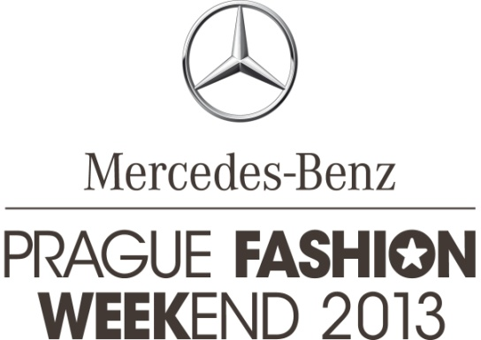

PRESS RELEASE | Prague, on June 6, 2013

WELL KNOWN FASHION DESIGNER JIMMY CHOO ACCEPTS INVITATION TO MERCEDES-BENZ PRAGUE FASHION WEEKEND 2013

This year, Prague Fashion Weekend has joined the global network of Mercedes-Benz fashion weeks. This means Mercedes-Benz Prague Fashion Weekend substantially strengthens its position, and is able to announce the first star in fashion design accepting the invitation to join the event – it is Jimmy Choo who will come to the Czech Republic. In Prague, Jimmy Choo will support young fashion designers, accompany the winner of Mercedes-Benz STYLO Awards Kuala Lumpur, and accept the patronage of an accompanying activity within the fashion event.

“I am delighted that Jimmy Choo has accepted our invitation and that he will support Mercedes-Benz Prague Fashion Weekend by his personal attendance. Jimmy Choo will spend 2 days in Prague, whereby the major aim of his journey is the support of local fashion designers. Already in spring we had the pleasure to present Czech designers at Mercedes-Benz STYLO Fashion Week Malaysia, thus launching the exchange of young talents within Mercedes-Benz Fashion Weeks. The collection of the designer trio La Formela has received ovations, putting Prague in the limelight and making it one of the most discussed topics at the gala evening. Jovian Mandagie, the winner of Mercedes-Benz Stylo Fashion GrandPrix, a competition that took part within the mentioned event, will introduce himself to the Czech visitors on Sunday as a special guest within the programme of Mercedes-Benz Prague Fashion Weekend 2013,” says Janina Šlemínová, managing director of Stars Communication.

MBPFW will be held from September 18 to September 22, 2013 in the attractive Pařížská Street in the very centre of Prague. This means that visitors will be even closer to boutiques and showrooms of Czech as well as foreign fashion designers and fashion brands. Close to the end of Pařížská there will be two fashion tents encompassing an area of 1,400 sqm. The first tent will serve as an entrance area and a spacious fashion lounge, the major communication area of visitors. The second tent will provide space for the main catwalk with a length of 30 m and a viewing area for 600 seating and 100 standing visitors. Mercedes-Benz Prague Fashion Weekend is similarly to all other fashion weeks focused primarily on the support and presentation of local fashion designers and brands. The four-day marathon of stand-alone fashion shows, showrooms, workshops and discussion panels will follow the motto of 2013, which is “Back to tradition and craft.”

A part of the event’s programme is committed to the young generation of raising stars among fashion designers. Also this year’s Mercedes-Benz Prague Fashion Weekend will feature START-UP, a competition for young designers. START-UP is a prestigious fashion contest for both students and fresh graduates of fashion and art schools located in the Czech Republic and Slovakia. The topic announced for this year is “the point of birth”. Emphasis will be put mainly on creativity, grasping and portraying of the topic, the treatment of materials used as well as the overall set-up and styling of the presented collection. An expert jury will choose 10 finalists in the clothing category, and 5 finalists in the fashion accessory category. The finalists will get the chance to present their collections at the final evening of Mercedes-Benz Prague Fashion Weekend, and winners will receive prize money. Submissions are received until June 7, with finalists being announced until the end of June.

A novelty this year is the presale and sale of tickets at the proprietary www.fashionweekend.cz website. Apart from single tickets visitors will be able to purchase also fashion passes valid for the entire event. Fashion passes may be reserved already now at the project website.

www.fashionweekend.cz

Media relations contact:
Zita Vinšová
EV Communications
Mob.: + 420 602 367 721
Tel.: + 420 233 373 273
vinsova@evcommunications.cz

stars communication
MERCEDES-BENZ PRAGUE FASHION WEEKEND is organised by Stars Communication, a joint venture of the renowned Czechoslovak Models modelling agency and SARA EVENTS. The joining of powers of these strong partners that have been operating in the Czech market already for 20 years enabled the creation of a unique concept combining the stable and professional background, wealth of experience as well as personal contacts of the partner companies.

www.starscom.cz | www.czModels.cz | www.saraevents.cz

